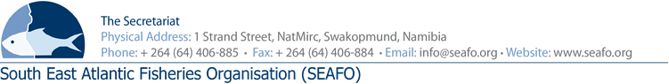
LIST OF DOCUMENTS FOR THE 16TH MEETING OF THE COMMISSION (COM) - 2019

CHAIRPERSON: Mr. Venâncio Soares Gomes (Angola 2017-2020) VENUE: Strand Hotel, Swakopmund
VICE-CHAIR: Mr. Luis Molledo (EU 2017-2020) DATE: 25 & 28 November 2019

Document Number | Agenda  Item | Document Title | Provider | Availability of Document
DOC/COM/00/2019 | 3 | List of documents | Secretariat | Available before meeting
DOC/COM/01/2019 | 3 | Provisional Agenda for the 16th Meeting of the Commission | Secretariat | Available before meeting
DOC/COM/02/2019 | 3 | Provisional Annotated Agenda for the 16th Meeting of the Commission | Secretariat | Available before meeting
DOC/COM/03/2019 | 8 | Scientific Committee Meeting Report for 2019 | SC | Available at the meeting
DOC/COM/04/2019 | 9 | Compliance Committee Meeting Report for 2019 | CC | Available at the meeting
DOC/COM/05/2019 | 10 | Standing Committee on Admin & Finance Meeting Report of 2019 | SCAF | Available at the meeting
DOC/COM/06/2019 | 11 | Feedback Report of the ABNJ Deep Seas Project 4th PSC meeting | Secretariat | Available before meeting
DOC/COM/07/2019 | 11 | Feedback Report on the IGC on a legally binding instrument under the UNCLOS on the conservation and sustainable use of marine BBNJ | Secretariat | Available before meeting
DOC/COM/08/2019 | 14 | Update on the ABNJ Deep Seas Project - 2019 | FAO ABNJ Deep see project coordinator | Available before meeting
DOC/COM/09/2019 | 8 | EAF-NANSEN Programme Data Policy August 2019 update DRAFT | EAF NANSEN Project | Available before meeting
DOC/COM/10/2019 | 14 | Request for IUU information of Cape Flower | Chairperson SPRFMO | Available before meeting
DOC/COM/11/2019 | 14 | Invitation for SEAFO contributions to A BETTER WORLD Publication | Ben Cornwell - Project Coordinator | Available before meeting
DOC/COM/12/2019 | 16 | Commission Meeting Report for 2019 | COM | Available at the meeting
Circulation Date: 25 October 2019

